



Submitted to :

(Supervisor’s Signature)

…………………………………..

Mr.Nishantha Gamage

Date of Submition

**EDUCATION CENTER MANAGEMENT SYSTEM**

Software Requirement Specification

(SRS)

JL/22/ICT5/1/0024 –(K.C. Dilshara Jayakodi)

**VOCATIONAL TRAINING AUTHORITY**

# Table of Contents

Table of Contents ii

Revision History ii

1. Introduction 1
   1. Purpose 1
   2. Document Conventions 2
   3. Intended Audience and Reading Suggestions 2
   4. Product Scope 2
   5. References 2
2. Overall Description 3
   1. Product Perspective 3
   2. Product Functions 3
   3. User Classes and Characteristics 4
   4. Operating Environment 5
   5. Design and Implementation Constraints 5
   6. Project Documentation 6
   7. User Documentation 7
   8. Assumptions and Dependencies 7
3. External Interface Requirements 7
   1. User Interfaces 8
   2. Hardware Interfaces 10
   3. Software Interfaces 10
   4. Communications Interfaces 10
4. System Features 11
5. Other Nonfunctional Requirements 12
   1. Performance Requirements 12
   2. Safety Requirements 12
   3. Security Requirements 13
   4. Web Quality Attributes 13
   5. Business Rules 13

# Revision History

|  |  |  |  |
| --- | --- | --- | --- |
| **Name** | **Date** | **Reason For Changes** | **Version** |
|  |  |  |  |
|  |  |  |  |

# Introduction

This is requirement specification document for an Education center management system. This document describes the scope, objectives and goals of the new system. In addition to describing nonfunctional requirement this document models the functional requirements with use case, ER diagram and DFD.

* 1. **Purpose**

The document is intended to be read by project manager developers user documentation writers. The document is organized into introduction overall description system features external interface requirement, what the system will do, the constraints under which it must operate and how the system will react to external stimuli. Understanding what order the functionality will be developed in means that we, the developers will have the "big picture" view of the development. This gives us an opportunity to plan ahead which saves both project time and cost.

* + 1. **Accuracy**

We will ensure the accuracy of the data entered to the database

* + 1. **Clarity**

This SRS will be clearly stating what the user wants in the web site.

* + 1. **Completeness**

The system requirement specification contains all the requirements stated in the business requirements documentation that the user specified.

* 1. **Document Conventions**

The document is prepared using Microsoft Word 2010.The followings are the list of standards and typographical conventions that used in this SRS document.

Main Section Titles Font: Calisto MT Size – 28

Titles Font : Calibri (Body) Bold Size – 14

The fixed font size : Calibri (Body) Size – 14

* 1. **Intended Audience and Reading Suggestions**

The intended audience of this document would be the Staff and Student Education center.

Finally, the above mentioned audience will be check this SRS document frequently to get a clear understand about this product as it go through in several design and implementation levels to ensure that the final system being completed by the given requirements.

**1.4 Product Scope**

Introducing Education center management system can reduce the time wasted It will enable you to manage your work efficiently.

* This system can record student attendance, update details.
* This system can search the student details.

**1.5 References**

[2]Lauesen, S, (2003), Task Descriptions as Functional Requirements, IEEE Computer Society,

Available:http://www.itu.dk/~slauesen/Papers/IEEEtasks.pdf

**2.1 Product Perspective**

Blending with technology can reduce human errors. Because the main subjects are covered in the same institution through the education management system, the students save time and the information of the students can be obtained in a short period of time**.** Data related to the project the use of a fast computer system for handling saves time, leaflets and manpower which further helps to provide better service to the society

**2.2 Product Functions**

* Student registration.
* Update registered Student details.
* Delete Student details.
* Search Student Details.

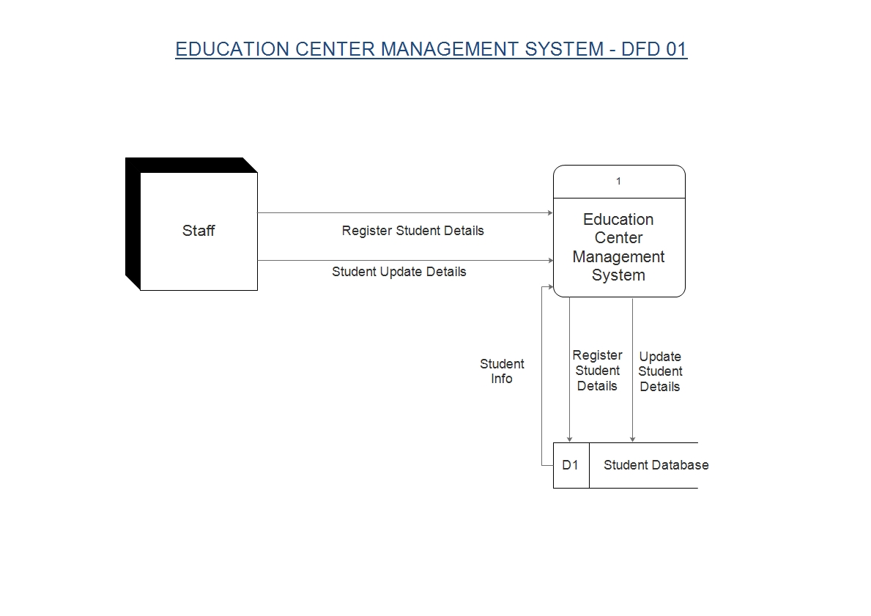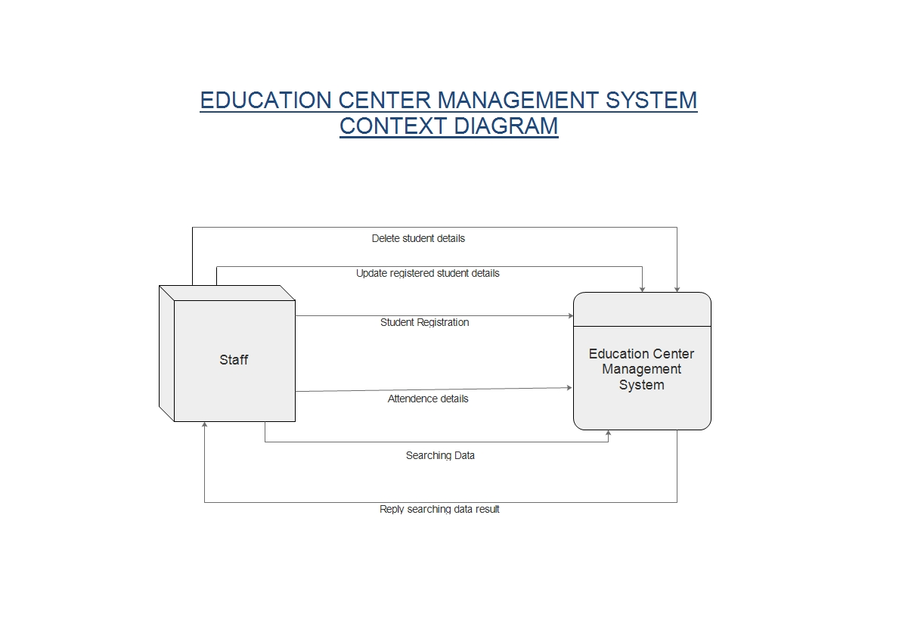**2.3 Context Diagram**

**2.3 User Classes and Characteristics**

* Staff

Staff has the full access to the system which means he is able to manage any activity with regard to the system. He is the highest privileged user who can access to the system.

Key Function

* Student registration.
* Update registered Student details.
* Delete Student details.
* Search Student Details.

**2.4 Operating Environment**

Software requirements

• Windows 10 or above operating system.

• Web Browser

• MySQL

• JRE 1.8

Hardware Requirements

* Core i3 processor
* 4GB Ram
* Internet Service provider

**2.5 Design and Implementation Constraints**

• User Name and password are required to login to the system.

• Database is password protected.

**2.6 Project Documentation**

|  |  |  |
| --- | --- | --- |
| Software Life Cycle Phase | Documentation | Intended Activities |
| Requirement Gathering, Analysis and Specification | * Project charter * Project proposal * Software Requirement and Specification (SRS) which includes * Entity relational diagram * Data flow diagrams * Use case diagrams | Includes the customer expected software features, constraints, interfaces and other attributes. Moreover the objectives and the benefits gained through the system are clearly specified |
| Software Design | * Software Design Description(SDD) | Describes the logical basis of design decisions taken and how it will have way in acquiring the requirements of the student  through the software |
| Implementation | * Technical Documentation | Contains information regarding the implementations of the system using the programming  concepts |
| Software Testing | * Software Test Documentation(STD) | Includes information degrading testing procedures to validate and verify the software results. Main types of testing techniques are unit testing, integration testing, system testing and acceptance  testing |
| Maintenance | * User Documentation | Includes manuals for the end users according to their position  of access levels |

**2.7 User Documentation**

The user manual will include the email addresses to contact us in need. Tasks are listed alphabetically or logically grouped often using cross referenced indexes which helps the users to know exactly what sort of information they are looking for.

**2.8 Assumptions and Dependencies**

* The user can register student and delete data.
* The charges of the service are calculated in this system

**3. External Interface Requirements**

**3.1 User Interfaces**

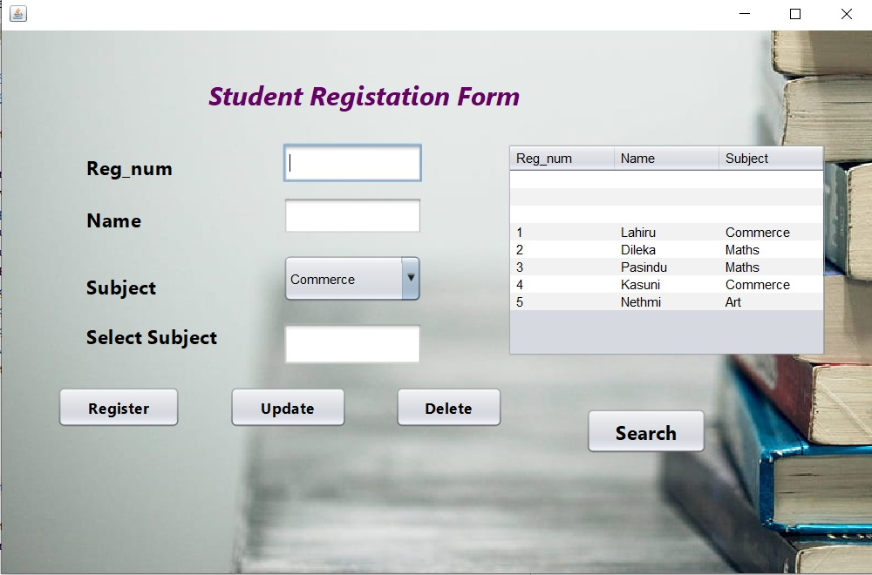**Register Form**

3.1.1

**Search Form**

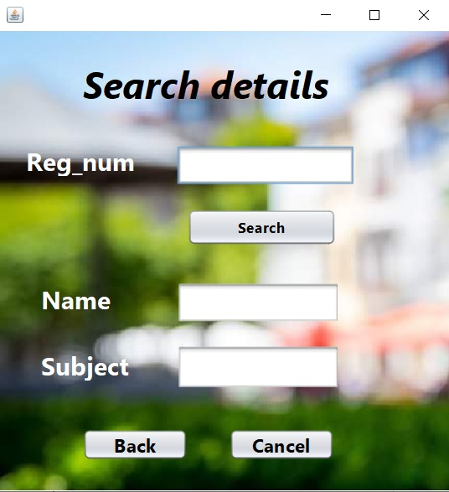

3.1.2

**3.2 Hardware Interfaces**

* Desktop PC
* core i5 processor
* 4GB RAM
* 500GB HD

**3.3 Software Interfaces**

**Developing end**

* Operating system : windows 7,10
* Application software :- o E-draw max o Visual studio 2012
* Word
* Power point
* Front end :- PHP my admin
* Back end :- Word press Plugin

**3.4 Communications Interfaces**

The web system shall use the HTTP protocol for communication over the internet and for the intranet communication.

**4. System Features**

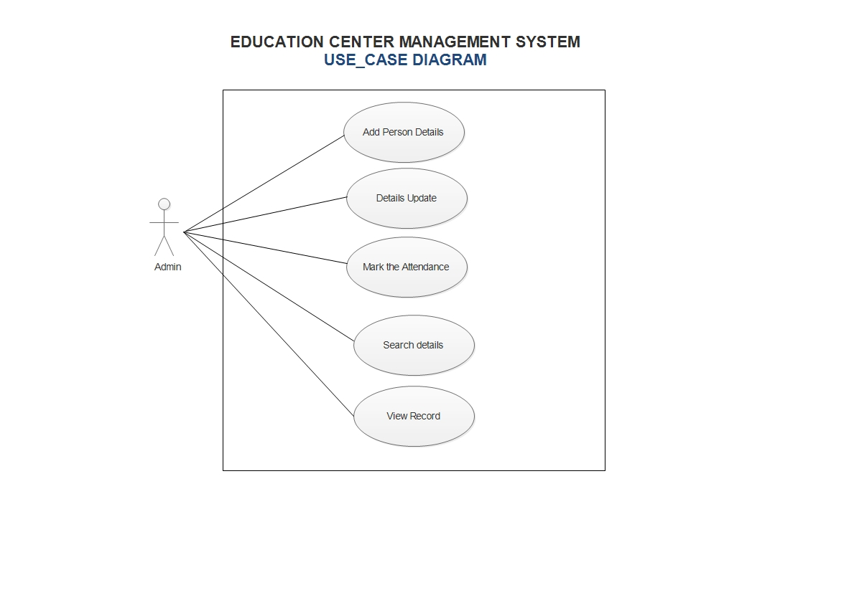**USE CASE Diagram**

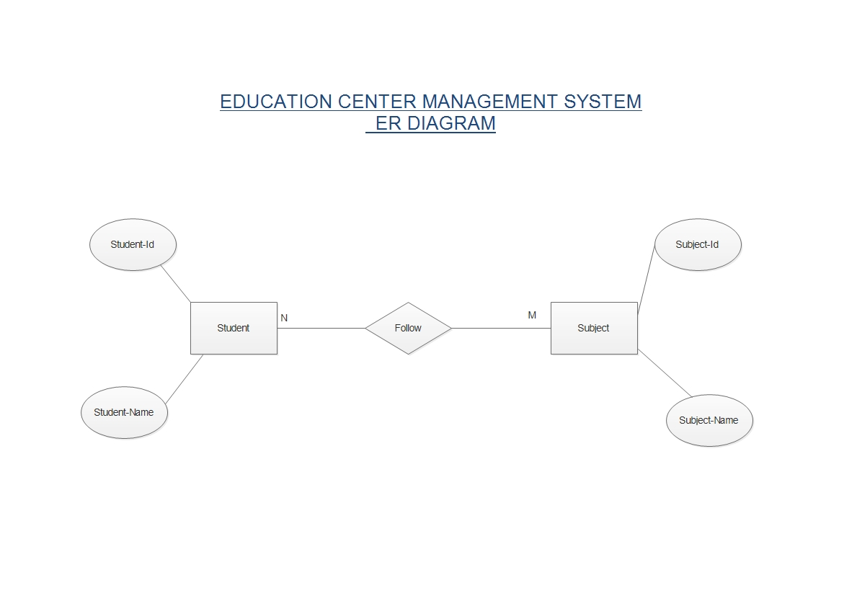**ER Diagram**

**Other Nonfunctional Requirements**

**5.1 Performance Requirements**

* Response time-The system will give responses within 1 second.
* Capacity-The system must support 50 people at a time.
* User interface- User interface screen will response quickly.

**5.2 Safety Requirements**

* Maintain the database.

**5.3 Security Requirements**

except system administrative nobody cannot change record and valuable data.

**5.4 Software Quality Attributes**

* AVAILABILITY: The system shall be available all the time.
* CORRECTNESS: A bug free system which fulfill the correct need/requirements of the client.
* MAINTAINABILITY: The ability to maintain, modify information and update fix problems of the system.
* USABILITY: System can be used again and again without distortion.
* Access: only administrator can access the system.
* ACCURACY: The reliability on the information/output. Can depend/be sure of the outcome.

**5.5 Business Rules**

* Warranty period of maintaining the system would be one year.
* Additional payments will be analyzed and charged for further maintenance.
* If any error occur due to a user’s improper use. Warranty will not be allocated to it.